Template for AuE 881 HW4
This solution to the HW assignment is organized by task. In each task, we follow the same template: set up the problem, solve it, plot/interpret the results, and answer the interpretation questions if there are any.
Initialization 1
Simulink parameter definitions 1
Task 1 2
Task 3 4
Task 4 11
End 16

Initialization
In general, the following two lines will make your code slower, but I suggest leaving them in for final testing so that you do not accidentally rely on stale result still existing in your workspace
clear all;
close all;
clc

Simulink parameter definitions
Define the vehicle parameters used in the Simulink model
mass = 1292; % total vehicle mass [kg]
WD = 0.6; % weight distribution [%] -- proportion on front axle
L = 2.54; % wheelbase [m]
Jz = 2380; % Moment of inertia of the vehicle [kgm^2]
Caf = 1450; % Tire cornering stiffness front [N/deg]
Car = 1290; % Tire cornering stiffness rear [N/deg]
Cmzf = 30; % Tire aligning stiffness front [Nm/deg]
Cmzr = 20; % Tire aligning stiffness rear [Nm/deg]
V = 40/3.6; % velocity [m/s] (40 kmph is 40/3.6 m/s)
% some derived quantities
a = (1-WD)*L; % front axle distance from cg [m]
b = WD*L ; % rear axle distance from cg [m]
% Define constants used in the Simulink model
g = 9.81; % gravity [m/s2]
% A few variable initializations necessary to make the initial Simulink
% template work -- Note: these values will need to be modified later for
% each simulation scenaria
steeringScenario = 1; % start by running the first scenario (constant input)
steerAngle = 5; % steer angle in [deg] for step input
enablePlotting = false; % turn on the plotting features (off is faster!)
maxYawRate = 20; % [rad/s] -- stop the simulation if yaw rate is >

Task 1
%calling the Simulink model, and displaying it
figure('Name','Vehicle Position');
HW4out1 = sim('HW4_Task2.slx',4);
disp(HW4out1.steer);
% ploting the Steering angle
figure(2)
plot(HW4out1.steer);
title('Steering Angle with Time')
xlabel('Time (s)')
ylabel('Steering Angle (degrees)')
% ploting the Yaw Rate
figure(3)
plot(HW4out1.yawrate);
title('Yaw Rate (degrees/s) with Time')
xlabel('Time (s)')
ylabel('Yaw Rate (degrees/s)')
% ploting the Vehicle Position
figure(4)
plot(HW4out1.X.Data,HW4out1.Y.Data);
title('Vehicle Position Y vs X')
xlabel('X')
ylabel('Y')
timeseries with properties:
Events: []
Name: ''
UserData: []
Data: [401×1 double]
DataInfo: [1×1 tsdata.datametadata]
Time: [401×1 double]
TimeInfo: [1×1 tsdata.timemetadata]
Quality: []
QualityInfo: [1×1 tsdata.qualmetadata]
IsTimeFirst: 1
TreatNaNasMissing: 1
Length: 401
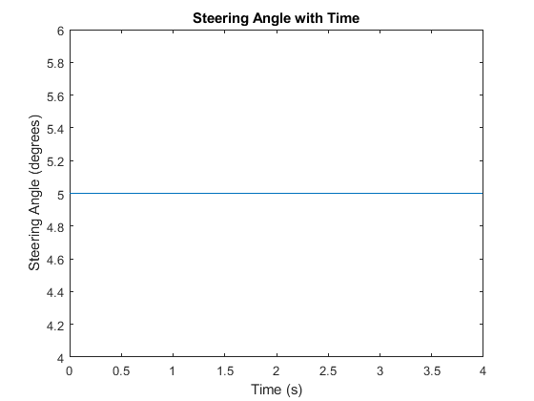
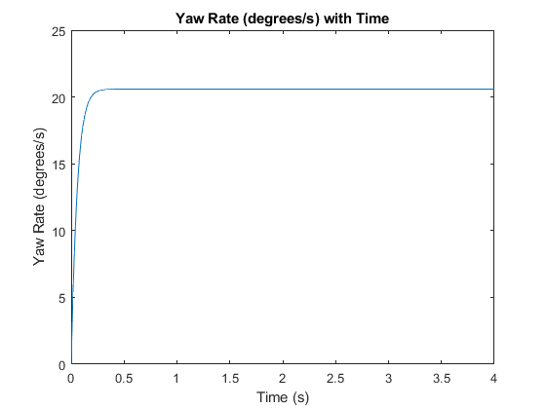
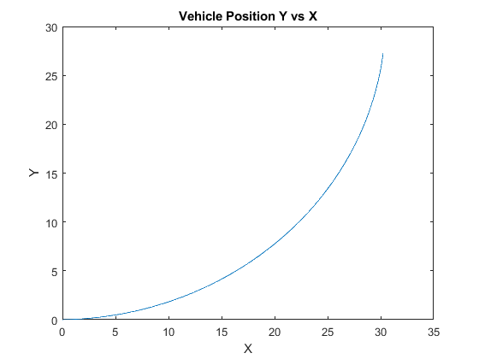

Task 3
% Scenario 1: A constant steering input – steeringScenario=1, steerAngle=5
steeringScenario = 1;
steerAngle = 5; % steer angle in [deg] for step input
enablePlotting = false; % turn on the plotting features (off is faster!)
maxYawRate = 20; % [rad/s] -- stop the simulation if yaw rate is >
%calling the Simulink model, and displaying it
HW4out1 = sim('HW4_Task2.slx',4);
% ploting the Steering angle
figure(5)
plot(HW4out1.steer);
title('Scenario 1: Steering Angle with Time')
xlabel('Time (s)')
ylabel('Steering Angle (degrees)')
% ploting the Yaw Rate
figure(6)
plot(HW4out1.yawrate);
title('Scenario 1: Yaw Rate (degrees/s) with Time')
xlabel('Time (s)')
ylabel('Yaw Rate (degrees/s)')
% ploting the Vehicle Position
figure(7)
plot(HW4out1.X.Data,HW4out1.Y.Data);
title('Scenario 1: Vehicle Position Y vs X')
xlabel('X')
ylabel('Y')
% % % % % % % % % % % % % % % % % % % % % % % % % % % % % % % % % % %
% Scenario 2: A left-right step steering input – steeringScenario=2, steerAngle=15
steeringScenario = 2;
steerAngle = 15; % steer angle in [deg] for step input
enablePlotting = false; % turn on the plotting features (off is faster!)
maxYawRate = 20; % [rad/s] -- stop the simulation if yaw rate is >
%calling the Simulink model, and displaying it
HW4out1 = sim('HW4_Task2.slx',4);
% ploting the Steering angle
figure(8)
plot(HW4out1.steer);
grid on
title('Scenario 2: Steering Angle with Time')
xlabel('Time (s)')
ylabel('Steering Angle (degrees)')
% ploting the Yaw Rate
figure(9)
plot(HW4out1.yawrate);
grid on
title('Scenario 2: Yaw Rate (degrees/s) with Time')
xlabel('Time (s)')
ylabel('Yaw Rate (degrees/s)')
% ploting the Vehicle Position
figure(10)
plot(HW4out1.X.Data,HW4out1.Y.Data);
grid on
title('Scenario 2: Vehicle Position Y vs X')
xlabel('X')
ylabel('Y')
% % % % % % % % % % % % % % % % % % % % % % % % % % % % % % % % % % % %
% Scenario 3: A left-right saw-tooth input – steeringScenario=3, steerAngle=15
steeringScenario = 3;
steerAngle = 15; % steer angle in [deg] for step input
enablePlotting = false; % turn on the plotting features (off is faster!)
maxYawRate = 20; % [rad/s] -- stop the simulation if yaw rate is >
%calling the Simulink model, and displaying it
HW4out1 = sim('HW4_Task2.slx',4);
% ploting the Steering angle
figure(11)
plot(HW4out1.steer);
grid on
title('Scenario 3: Steering Angle with Time')
xlabel('Time (s)')
ylabel('Steering Angle (degrees)')
% ploting the Yaw Rate
figure(12)
plot(HW4out1.yawrate);
grid on
title('Scenario 3: Yaw Rate (degrees/s) with Time')
xlabel('Time (s)')
ylabel('Yaw Rate (degrees/s)')
% ploting the Vehicle Position
figure(13)
plot(HW4out1.X.Data,HW4out1.Y.Data);
grid on
title('Scenario 3: Vehicle Position Y vs X')
xlabel('X')
ylabel('Y')
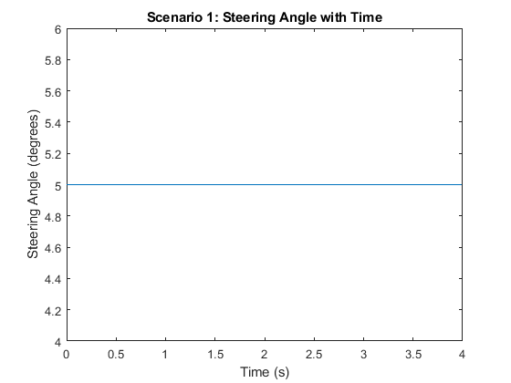
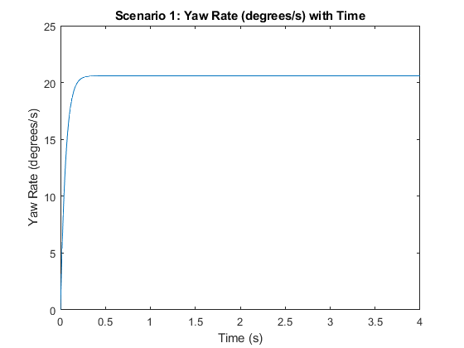
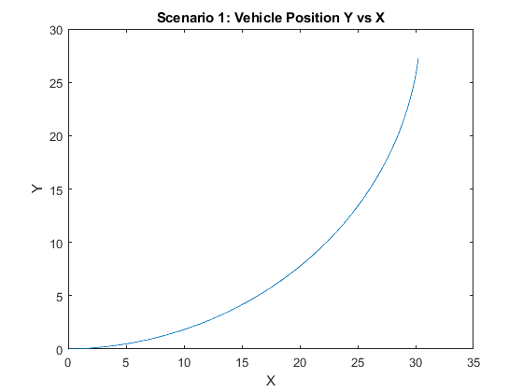
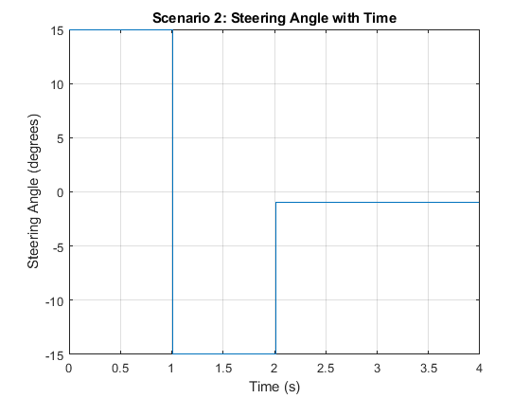
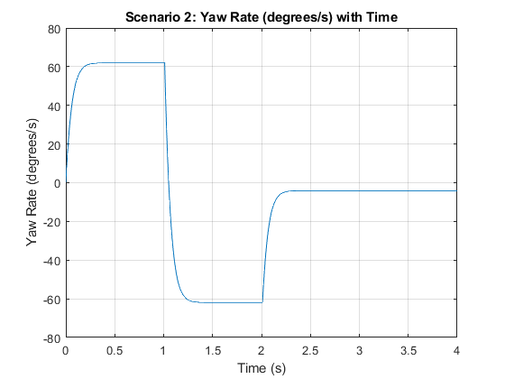
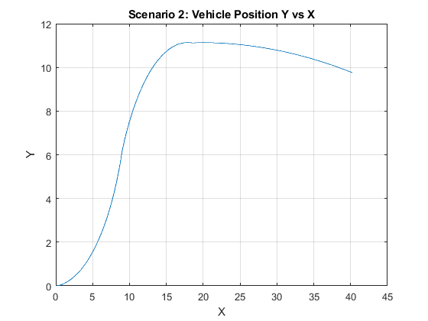
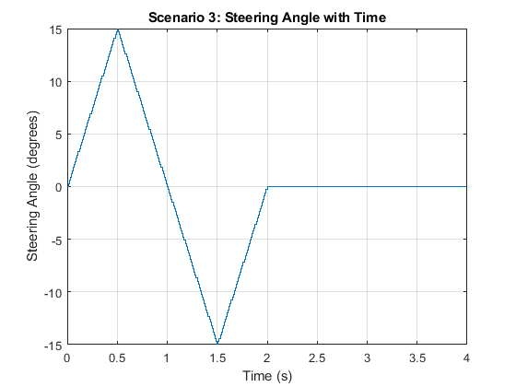
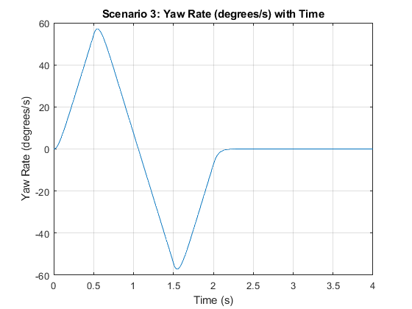
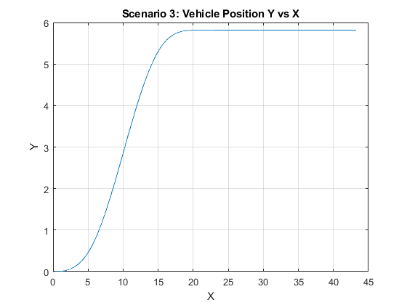

Task 4
% % % % % % % % % % % % % % % % % % % % % % % % % % % % % % % % % % %
% Task 4.1
R=100;
steeringScenario = 1; % constant steering
steerAngle = (L/R)*(180/pi); % Ackermann steering angle in [deg]
enablePlotting = false; % turn on the plotting features (off is faster!)
maxYawRate = 20; % [rad/s] -- stop the simulation if yaw rate is >
V = 1/3.6; % velocity [m/s] (1 kmph is 40/3.6 m/s)
%calling the Simulink model, and displaying it
HW4out1 = sim('HW4_Task2.slx',20);
% ploting the Vehicle Position
figure(15)
plot(HW4out1.X.Data,HW4out1.Y.Data);
grid on
title('Task 4.1: Vehicle Position - Ackermann steering angle and 1 km/h with 1000s run time')
xlabel('X')
ylabel('Y')
% calculating the simulated turning radius
Turning_data=[HW4out1.X.Data HW4out1.Y.Data];
[Lc,R,K] = curvature(Turning_data); % external function
mean(R(50:end-1,:)) % excluding the first 50 points before the steady speed
% % % % % % % % % % % % % % % % % % % % % % % % % % % % % % % % % % %
% Task 4.2
i=1;
V = [1, 30, 60, 90, 120, 140, 150, 160, 170, 180]./3.6;
Radiud_per_velocity=zeros(length(V),2);
for V=V
% calling the Simulink model, and displaying it
HW4out1 = sim('HW4_Task2.slx',15);
% ploting the Vehicle Position
figure(16)
plot(HW4out1.X.Data,HW4out1.Y.Data,'LineWidth',1);
grid on
title('Task 4.2: Vehicle Position - Ackermann steering angle at different speeds')
xlabel('X')
ylabel('Y')
hold on
% calculating the simulated turning radius for each velocity
Turning_data=[HW4out1.X.Data HW4out1.Y.Data];
[Lc,R,K] = curvature(Turning_data); % external function
m=mean(R(50:end-1,:)); % excluding the first 50 points before the steady speed
Radiud_per_velocity(i,1)=V;
Radiud_per_velocity(i,2)=m;
i=i+1;
end
clear i;
legend('1','30', '60', '90', '120', '140', '150', '160', '170', '180')
% plotting the simulated turning radius for each velocity
figure(17)
axis equal
plot(Radiud_per_velocity(:,1),Radiud_per_velocity(:,2),'o-');
grid on
title('Task 4.2: Average Turning Radius per Velocity')
xlabel('The Longitudinal Velocity')
ylabel('Average Turning Radius')
% computing understeer gradient
Kus=((WD*mass)/(2*Caf))-(((1-WD)*mass)/(2*Car))
if Kus>0
Vehicle_condition='The vehicle Understeers'
else
Vehicle_condition='The vehicle Oversteers'
end
% % % % % % % % % % % % % % % % % % % % % % % % % % % % % % % % % % %
% Task 4.3
Caf=3000; % Changing front tire cornering stiffness front [N/deg]
maxYawRate = 20; % [rad/s] -- stop the simulation if yaw rate is >
i=1;
V = [1, 30, 60, 90, 120, 140, 150, 160, 170, 180]./3.6;
Radiud_per_velocity=zeros(length(V),2);
for V=V
% calling the Simulink model, and displaying it
HW4out1 = sim('HW4_Task2.slx',15);
% ploting the Vehicle Position
figure(18)
plot(HW4out1.X.Data,HW4out1.Y.Data,'LineWidth',1);
grid on
title('Task 4.3: Vehicle Position - Ackermann steering angle at different speeds - Caf=3000[N/deg]')
xlabel('X')
ylabel('Y')
hold on
i=i+1;
end
clear i;
legend('1','30', '60', '90', '120', '140', '150', '160', '170', '180')
% computing understeer gradient
Kus=((WD*mass)/(2*Caf))-(((1-WD)*mass)/(2*Car))
if Kus>0
Vehicle_condition='The vehicle Understeers'
else
Vehicle_condition='The vehicle Oversteers'
end
% computing the oversteering critical velocity [km/h]
The_critical_velocity=sqrt(-L/(Kus*pi/180))*3.6
ans =
99.9814
Kus =
0.0670
Vehicle_condition =
'The vehicle Understeers'
Kus =
-0.0711
Vehicle_condition =
'The vehicle Oversteers'
The_critical_velocity =
162.8603
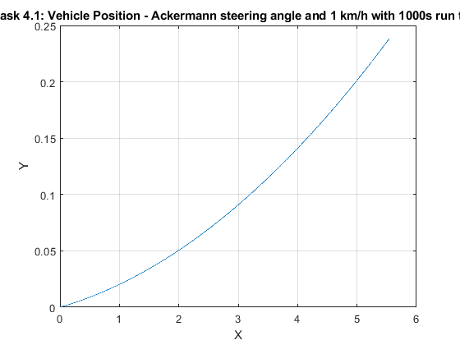
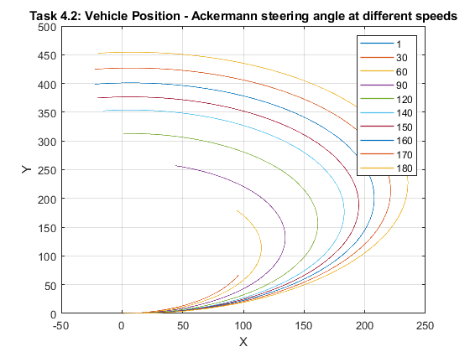
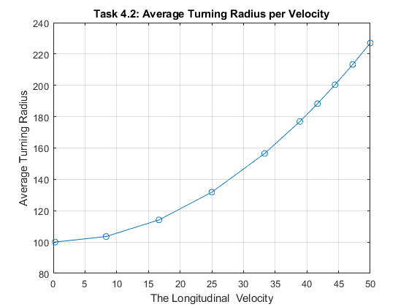
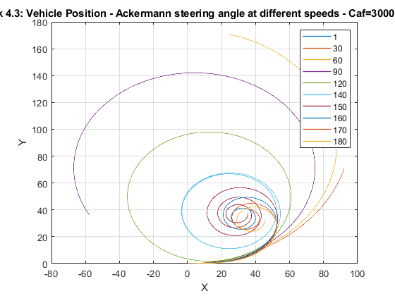

End
Published with MATLAB® R2020a

